DESIGN PRINCIPLES AND PATTERNS
Exercise 1: Implementing the Singleton Pattern
Scenario:
You need to ensure that a logging utility class in your application has only one instance throughout the application lifecycle to ensure consistent logging.
Steps:
- Create a New Java Project:
  - Create a new Java project named SingletonPatternExample.
- Define a Singleton Class:
  - Create a class named Logger that has a private static instance of itself.
  - Ensure the constructor of Logger is private.
  - Provide a public static method to get the instance of the Logger class.
- Implement the Singleton Pattern:
  - Write code to ensure that the Logger class follows the Singleton design pattern.
- Test the Singleton Implementation:
  - Create a test class to verify that only one instance of Logger is created and used across the application.
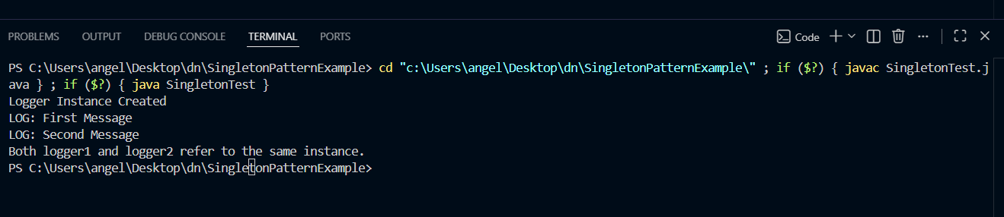
Exercise 2: Implementing the Factory Method Pattern
Scenario:
You are developing a document management system that needs to create different types of documents (e.g., Word, PDF, Excel). Use the Factory Method Pattern to achieve this.
Steps:
- Create a New Java Project:
  - Create a new Java project named FactoryMethodPatternExample.
- Define Document Classes:
  - Create interfaces or abstract classes for different document types such as WordDocument, PdfDocument, and ExcelDocument.
- Create Concrete Document Classes:
  - Implement concrete classes for each document type that implements or extends the above interfaces or abstract classes.
- Implement the Factory Method:
  - Create an abstract class DocumentFactory with a method createDocument().
  - Create concrete factory classes for each document type that extends DocumentFactory and implements the createDocument() method.
- Test the Factory Method Implementation:
  - Create a test class to demonstrate the creation of different document types using the factory method.
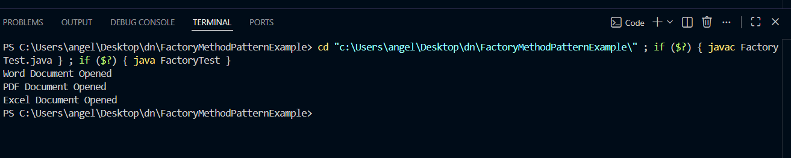
DATA STRUCTURES AND ALGORITHMS
Exercise 2: E-commerce Platform Search Function
Scenario:
You are working on the search functionality of an e-commerce platform. The search needs to be optimized for fast performance.
Steps:
- Understand Asymptotic Notation:
  - Explain Big O notation and how it helps in analyzing algorithms.
  - Describe the best, average, and worst-case scenarios for search operations.
- Setup:
  - Create a class Product with attributes for searching, such as productId, productName, and category.
- Implementation:
  - Implement linear search and binary search algorithms.
  - Store products in an array for linear search and a sorted array for binary search.
- Analysis:
  - Compare the time complexity of linear and binary search algorithms.
  - Discuss which algorithm is more suitable for your platform and why.
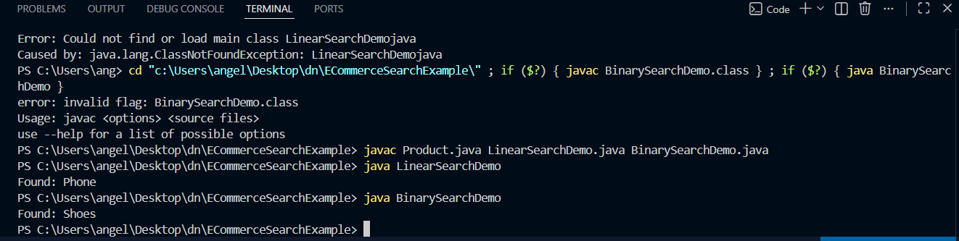
Exercise 7: Financial Forecasting
Scenario:
You are developing a financial forecasting tool that predicts future values based on past data.
Steps:
- Understand Recursive Algorithms:
  - Explain the concept of recursion and how it can simplify certain problems.
- Setup:
  - Create a method to calculate the future value using a recursive approach.
- Implementation:
  - Implement a recursive algorithm to predict future values based on past growth rates.
- Analysis:
  - Discuss the time complexity of your recursive algorithm.
  - Explain how to optimize the recursive solution to avoid excessive computation.

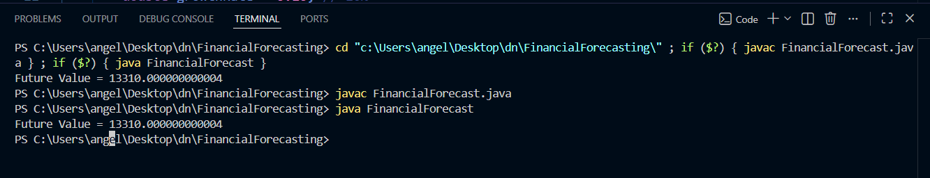

Calculation
Year 0 = 10000
Year 1 = 10000 × 1.10
= 11000
Year 2 = 11000 × 1.10
= 12100
Year 3 = 12100 × 1.10
= 13310

public class FinancialForecast {

// Recursive method
public static double forecast(double currentValue,
double growthRate,
int years) {

// Base case
if (years == 0) {
return currentValue;
}

return forecast(currentValue * (1 + growthRate),
growthRate,
years - 1);
}

public static void main(String[] args) {

double currentValue = 10000;
double growthRate = 0.10; // 10%
int years = 3;

double futureValue =
forecast(currentValue, growthRate, years);

System.out.println("Future Value = " + futureValue);
}
}

PL/SQL PROGRAMMING
Exercise 1: Control Structures

Scenario 1: The bank wants to apply a discount to loan interest rates for customers above 60 years old.
  - Question: Write a PL/SQL block that loops through all customers, checks their age, and if they are above 60, apply a 1% discount to their current loan interest rates.
Scenario 2: A customer can be promoted to VIP status based on their balance.
  - Question: Write a PL/SQL block that iterates through all customers and sets a flag IsVIP to TRUE for those with a balance over $10,000.
Scenario 3: The bank wants to send reminders to customers whose loans are due within the next 30 days.
  - Question: Write a PL/SQL block that fetches all loans due in the next 30 days and prints a reminder message for each customer.
Exercise 3: Stored Procedures

Scenario 1: The bank needs to process monthly interest for all savings accounts.
  - Question: Write a stored procedure ProcessMonthlyInterest that calculates and updates the balance of all savings accounts by applying an interest rate of 1% to the current balance.

Scenario 2: The bank wants to implement a bonus scheme for employees based on their performance.
  - Question: Write a stored procedure UpdateEmployeeBonus that updates the salary of employees in a given department by adding a bonus percentage passed as a parameter.

Scenario 3: Customers should be able to transfer funds between their accounts.
  - Question: Write a stored procedure TransferFunds that transfers a specified amount from one account to another, checking that the source account has sufficient balance before making the transfer.

TDD USING JUNIT5 AND MOCKITO
Exercise 1: Setting Up JUnit
Scenario:
You need to set up JUnit in your Java project to start writing unit tests.
Steps:
1. Create a new Java project in your IDE (e.g., IntelliJ IDEA, Eclipse).
2. Add JUnit dependency to your project. If you are using Maven, add the following to your
pom.xml:
<dependency>
<groupId>junit</groupId>
<artifactId>junit</artifactId>
<version>4.13.2</version>
<scope>test</scope>
</dependency>
3. Create a new test class in your project.
Exercise 3: Assertions in JUnit
Scenario:
You need to use different assertions in JUnit to validate your test results.
Steps:
1. Write tests using various JUnit assertions.
Solution Code:
public class AssertionsTest {
@Test
public void testAssertions() {
// Assert equals
assertEquals(5, 2 + 3);
// Assert true
assertTrue(5 > 3);
// Assert false
assertFalse(5 < 3);
// Assert null
assertNull(null);
// Assert not null
assertNotNull(new Object());
}
}
Exercise 4: Arrange-Act-Assert (AAA) Pattern, Test Fixtures, Setup and
Teardown Methods in JUnit
Scenario:
You need to organize your tests using the Arrange-Act-Assert (AAA) pattern and use setup
and teardown methods.
Steps:
1. Write tests using the AAA pattern.
2. Use @Before and @After annotations for setup and teardown methods.

Exercise 1: Mocking and Stubbing
Scenario:
You need to test a service that depends on an external API. Use Mockito to mock the
external API and stub its methods.
Steps:
1. Create a mock object for the external API.
2. Stub the methods to return predefined values.
3. Write a test case that uses the mock object.
Solution Code:
import static org.mockito.Mockito.*;
import org.junit.jupiter.api.Test;
import org.mockito.Mockito;
public class MyServiceTest {
@Test
public void testExternalApi() {
ExternalApi mockApi = Mockito.mock(ExternalApi.class);
when(mockApi.getData()).thenReturn("Mock Data");
MyService service = new MyService(mockApi);
String result = service.fetchData();
assertEquals("Mock Data", result);
}
}
Exercise 2: Verifying Interactions
Scenario:
You need to ensure that a method is called with specific arguments.
Steps:
1. Create a mock object.
2. Call the method with specific arguments.
3. Verify the interaction.
Solution Code:
import static org.mockito.Mockito.*;
import org.junit.jupiter.api.Test;
import org.mockito.Mockito;
public class MyServiceTest {
@Test
public void testVerifyInteraction() {
ExternalApi mockApi = Mockito.mock(ExternalApi.class);
MyService service = new MyService(mockApi);
service.fetchData();
verify(mockApi).getData();
}
}

SLF4J LOGGING FRAMEWORK
Exercise 1: Logging Error Messages and Warning Levels
Task: Write a Java application that demonstrates logging error messages and warning levels
using SLF4J.
Step-by-Step Solution:
1. Add SLF4J and Logback dependencies to your `pom.xml` file:
<dependency>
<groupId>org.slf4j</groupId>
<artifactId>slf4j-api</artifactId>
<version>1.7.30</version>
</dependency>
<dependency>
<groupId>ch.qos.logback</groupId>
<artifactId>logback-classic</artifactId>
<version>1.2.3</version>
</dependency>
2. Create a Java class that uses SLF4J for logging:
import org.slf4j.Logger;
import org.slf4j.LoggerFactory;
public class LoggingExample {
private static final Logger logger = LoggerFactory.getLogger(LoggingExample.class);
public static void main(String[] args) {
logger.error("This is an error message");
logger.warn("This is a warning message");
}
}

